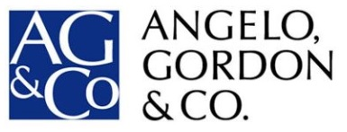

FOR IMMEDIATE RELEASE
Media Contacts:

For Atlantic Realty Companies
Leslie Braunstein
202.656.0542
info@lhbcommunciations.com

For Angelo, Gordon & Co.
Gasthalter & Co.
Nathaniel Garnick/Amanda Klein
212.257.4170

Atlantic Realty and Angelo, Gordon Acquire Tysons (VA) Office Complex for $78.8 Million

$6 Million Renovation Planned for 348,000 SF Property Near Metro

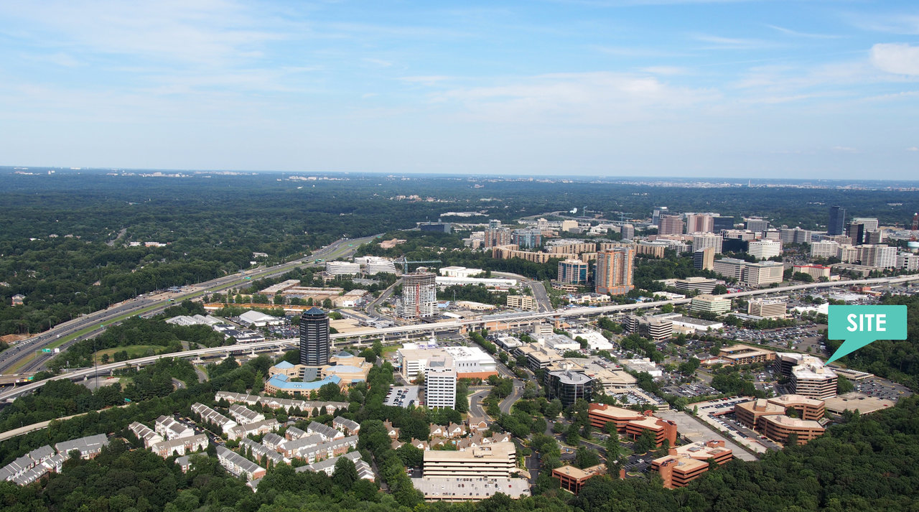

Tysons, VA, (October __, 2016) – Atlantic Realty Companies of Tysons, VA (“Atlantic”) and New York-based alternative investment firm Angelo, Gordon & Co. today announced that they have acquired Tysons Concourse from California State Teachers' Retirement System (CalSTRS) for $78.8 million. Tysons Concourse consists of two Class A office buildings located near Atlantic's headquarters in the heart of rapidly transforming Tysons, VA. CalSTRS was represented by Eastdil Secured in the transaction.

Situated just one block from the recently opened Spring Hill station on Metrorail’s Silver Line, the buildings have a total of 347,684 square feet of space and are 76 percent leased to a variety of tenants including Frontpoint Security, Konica Minolta, and MassMutual. Last year, Atlantic and Angelo, Gordon teamed up to acquire four office buildings with a total of nearly 500,000 SF of space in Reston, VA, close to the Wiehle Avenue station on Metro’s Silver Line.

Completed in 1987, the twin Tysons Concourse structures at 1593-95 Spring Hill Road are surrounded by extensive landscaping and joined by an atrium. Onsite amenities include a café, lighted basketball courts, theater-style conference center, fitness center with spa-style locker rooms, and covered and surface parking.

The Atlantic/Angelo, Gordon partnership has planned a $6 million renovation to completely update the physical building environment and amenities in order to appeal to today’s office tenant seeking to locate just steps from a key Metro stop in the new transit-oriented Tysons. The property’s lobby will be upgraded with marble flooring, a concierge desk, and interactive touchscreen directories. The front and rear entrances will feature new curtainwall, and a Terraneo coating will update the exposed aggregate precast façade.

Part of the existing sports area will be transformed into an outdoor lounge and seating area for tenants' use, along with an additional court for playing paddle tennis. Inside, the expansive conference facility will be upgraded with new finishes and a redesigned tenant/employee entertainment center.

“Tysons Concourse provides an excellent opportunity for us to participate further in the evolution of Tysons Corner from a suburban office enclave to a booming live-work-play transit-oriented community,” said David A. Ross, President, Atlantic Realty. “Along with our partners at Angelo, Gordon, we are very bullish on the future of this gateway to northern Virginia on Metrorail's Silver Line.”

Christina Lyndon Winstead, Managing Director, Angelo, Gordon, added, “We are pleased to continue our partnership with Atlantic Realty and to invest in the attractive and growing Tysons, VA, market.”

Since the Silver Line opened in 2014, Tysons has grown to encompass more than 28 million square feet of office space and over 10,000 multifamily housing units, with several thousand additional units scheduled to deliver over the next two years. Already the nation's 12th largest business district, Tysons is expected to have 100,000 residents and 200,000 jobs by 2050.

About Atlantic Realty Companies
Founded in 1992, Atlantic Realty Companies is a full-service real estate firm that owns, manages, and/or has developed an award-winning portfolio comprising of five million square feet of office and retail space located in Virginia, Maryland, and Delaware. Atlantic Realty succeeds in a wide spectrum of real estate projects, applying in-house capabilities that integrate acquisition, development, land use, leasing, construction, and property management. For more information, visit www.arcrealty.com or call 703.760.9500.

About Angelo, Gordon & Co.
Angelo, Gordon & Co., L.P. is a privately held limited partnership founded in November 1988, and currently manages approximately $26 billion. The Firm's investment focus centers around three core competencies - credit, real estate, and private equity. Angelo, Gordon has approximately 370 employees, approximately 140 of whom are investment professionals, and is headquartered in New York, with associated offices elsewhere in the US, Europe and Asia. For more information, visit www.angelogordon.com.

