FOR IMMEDIATE RELEASE:

News Media Contact: Adam Schulman
703.760.9500 adam@arcrealty.com

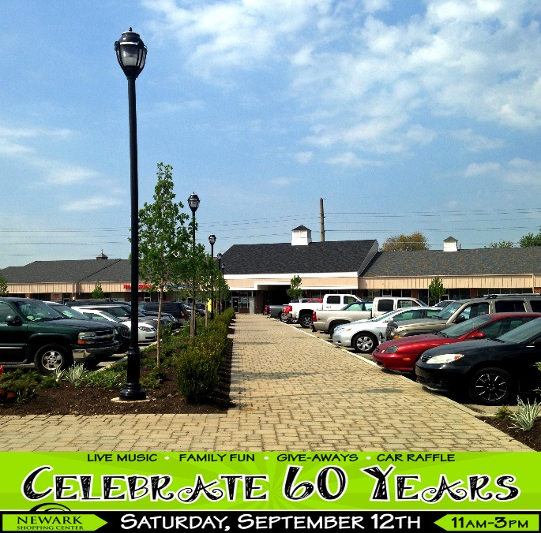
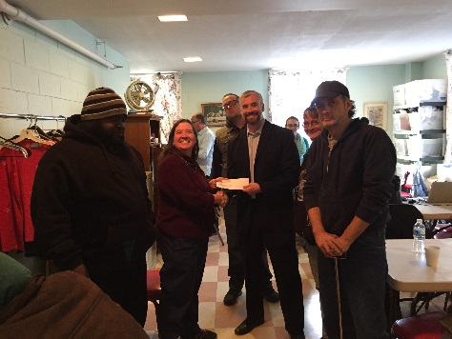
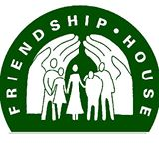
Atlantic Realty Companies and Angelo Gordon donate raffle money from Grand Re-Opening to Friendship House in Newark, DE.
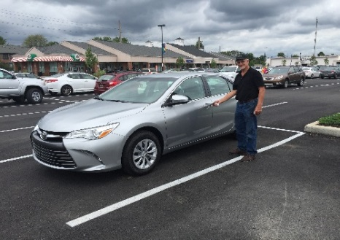
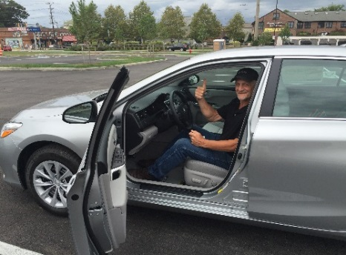
Photos: Newark Shopping Center (left); ARC employee: Chris Coffman presenting proceeds to Friendship House (middle); William Bloothoofd, Camry winner (right)

Atlantic Realty Companies and Angelo Gordon are pleased to announce that on September 12, 2015, at the grand re-opening of the Newark Shopping Center in Newark, DE which celebrated 60 years of operation and the completion of the renovation of the Center, the car raffle winner for a 2 year lease on a Toyota Camry from Toyota World was William Bloothoofd. Ticket proceeds to benefit Friendship House; a local non-profit group servicing the needs of the homeless.

