Atlantic Realty Companies Sponsorship of A New Night Downtown

Atlantic Realty Companies is named on the A New Night Downtown page on the Downtown Newark Partnership website, enjoydowntownnewark.com.
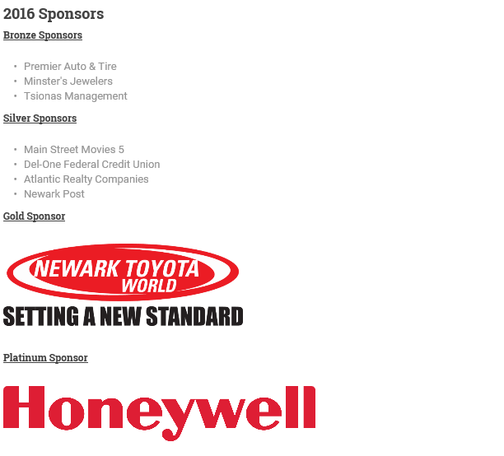

Atlantic Realty Companies was named in two newsletters that were sent to the event’s vendors prior to the event, as well as one newsletter that was sent after the event.
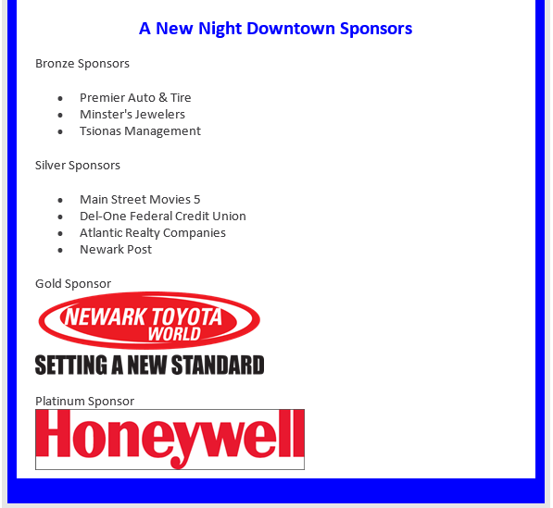

Atlantic Realty Companies was named in a post in the A New Night Downtown Facebook event through the Downtown Newark Partnership’s Facebook page.
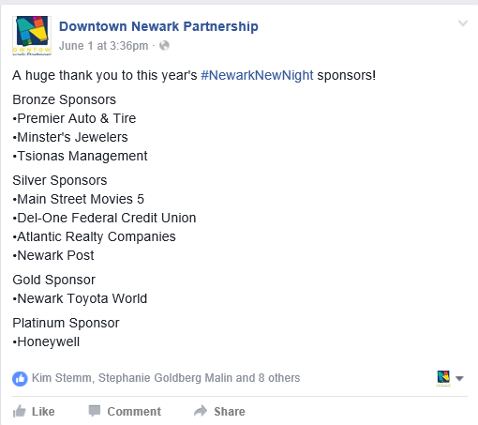

Atlantic Realty Companies was named on two banners that were hanging during A New Night Downtown on June 11.
