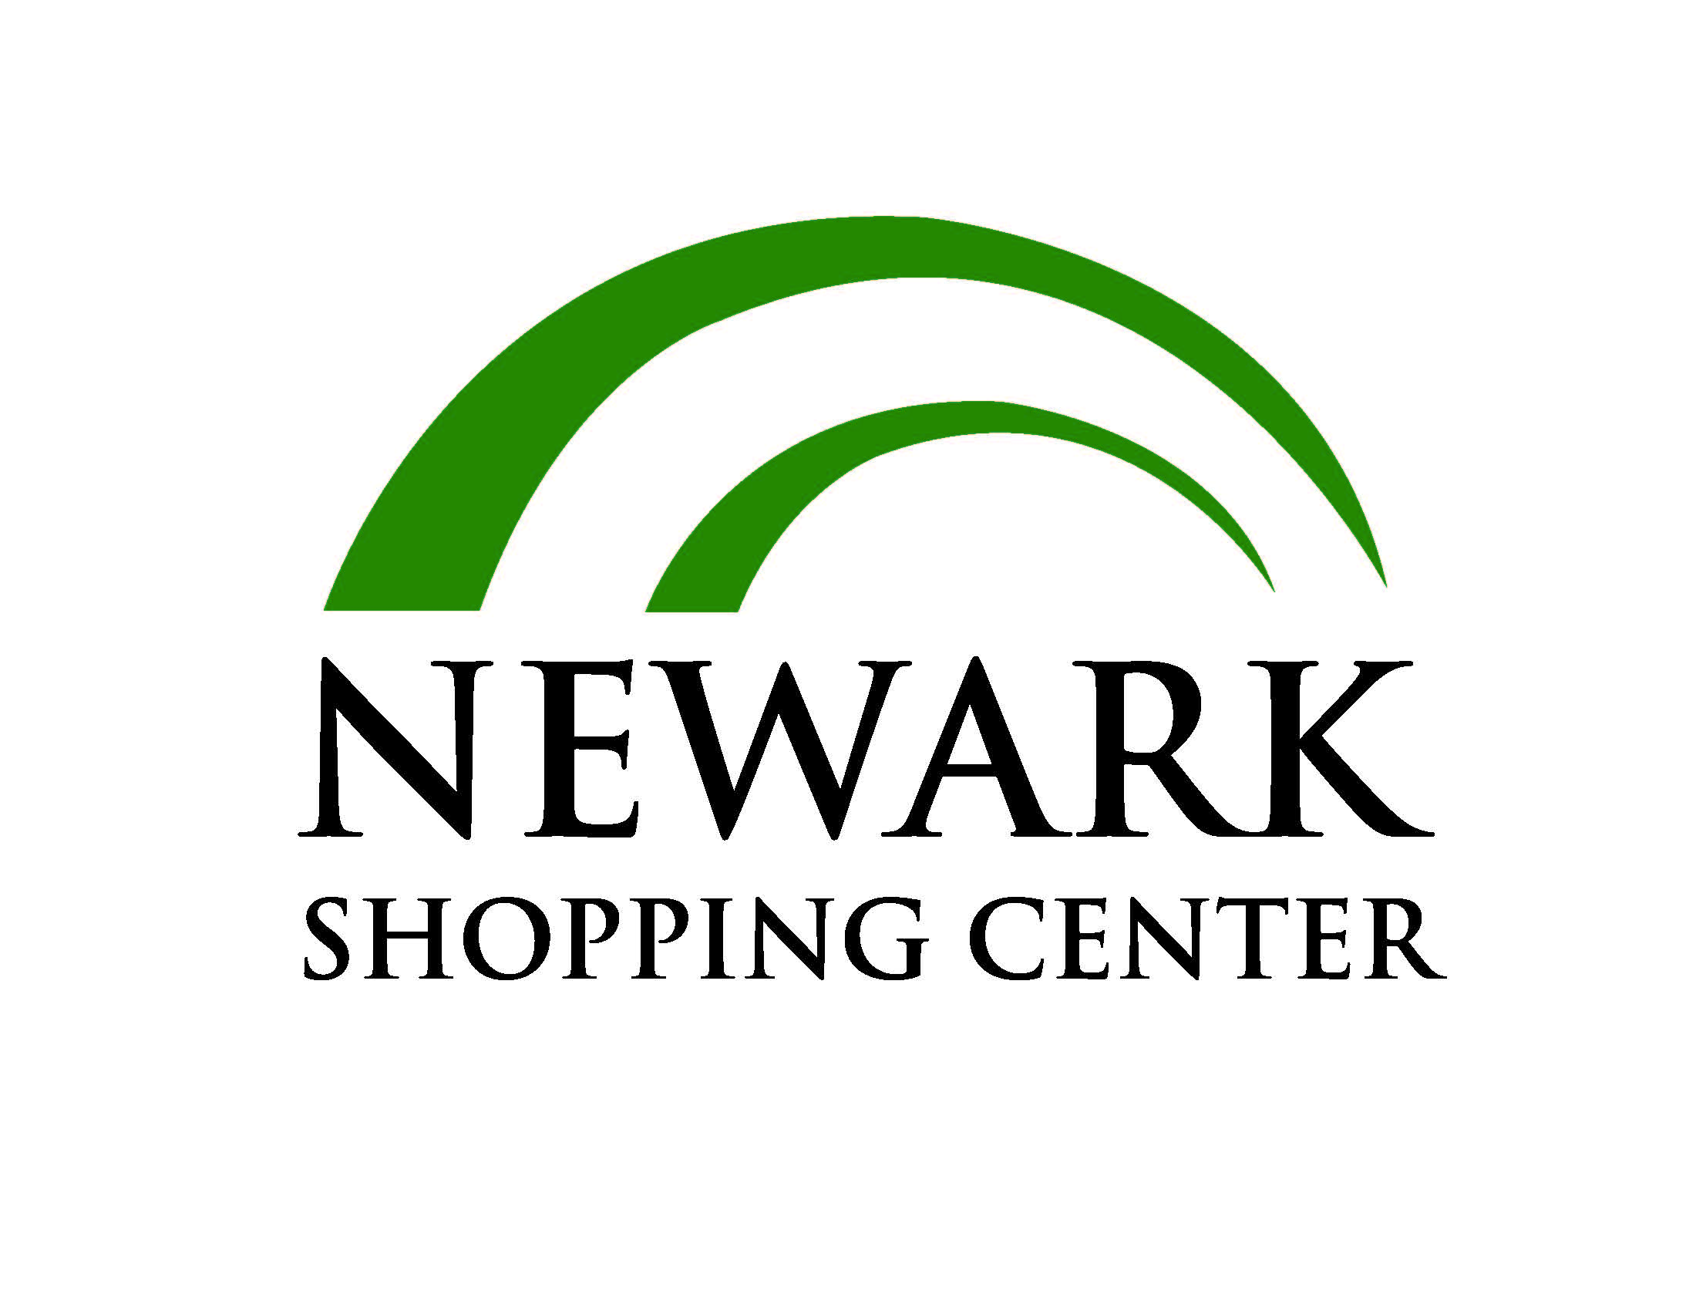

FOR IMMEDIATE RELEASE
News media contact: Leslie Braunstein
202.656.0542 – info@lhbcommunciations.com

Main Street Movies 5 to Open in 2016 at
Newark (DE) Shopping Center

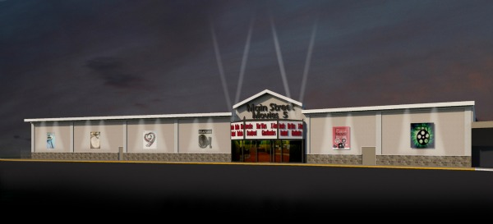

Newark, DE, (January 18, 2016) – Main Street Movies 5 will open a five-screen, state-of-the-art movie theater with reserved, reclining seats and refreshments from local vendors at the Newark (DE) Shopping Center in August of 2016. The new theater will replace the shuttered Newark Cinema Center, which operated from the early 1960’s through October of 2015.

Main Street Movies 5 has signed an 18,000 square foot lease with Atlantic Realty Companies of Tysons, VA, which acquired the Newark Shopping Center four years ago in partnership with New York City-based Angelo, Gordon & Co. Main Street will invest $3 million in a full-scale renovation of the old theater including expansion into adjacent space. The work is scheduled to begin in February 2016, without affecting operation of the rest of the shopping center.

In addition to offering roomy recliner seats and reserved seating, the new theater will offer a full bar, a 50-foot screen, self-serve ticketing, and a wide variety of grab-and-go concession offerings.

"We believe in being part of the community,” said Rick Roman, Principal of Main Street Movies 5. “In addition to the typical movie theater fare, we plan to sell locally made refreshments including pizza, cookies, and ice cream."

While the former outdated theater had three screens, the new theater will have five screens. "With cozy recliner seating, the new theater will have fewer seats than the old theatre so there will be plenty of parking," Roman noted. “Main Street Movies 5 will be a 21st Century theatre with the latest in technology to create a great theatre experience for moviegoers.”

“We are excited to bring a new, modern movie theater to Newark Shopping Center, the second oldest shopping center in Delaware,” said Atlantic Realty President David Ross. “Along with our partners at Angelo, Gordon, we are happy to be able to maintain this amenity for the City of Newark. Having a theater operated by professionals who are community-oriented will go a long way toward ensuring a successful operation.”

In late 2015, Atlantic Realty completed a $10 million renovation of the 61-year-old Newark Shopping Center to serve the needs of customers flocking to Newark’s vibrant Main Street corridor and the nearby University of Delaware campus. A grand opening celebration was held on September 12, 2015.

The center is now home to Newark Natural Foods, PNC Bank, Rita’s Italian Ice, Dollar Tree, Mediterranean Grill, Zahra International Foods, Mayflower Japanese Restaurant, Churrascaria Saudades Brazilian Steakhouse, Capriotti’s Sandwich Shop, Sports Clips, Big Z Pizza, and other retailers. Welcoming these new shops and restaurants are two tenants of long standing: Hair Design by Anthony and the only remaining original tenant from 1955, Minster’s Jewelers.

Newark Shopping Center was developed originally by Pomeroy Realty, Inc. at a cost of $1 million – an eye-popping figure at the time. Fourteen of the center’s 16 acres were devoted to parking, accommodating Americans’ postwar love affair with the automobile. The original tenant roster included Acme Super Market, Newark Department Store, F.W. Woolworth, Sun-Ray Drug Store, Miles Shoes, Liedemann’s Bakery, and J. J. Minster and Son.

Founded in 1992, Atlantic Realty Companies is a full-service real estate firm that owns, manages, and/or has developed an award-winning portfolio comprising four million square feet of office and retail space located in Virginia, Maryland, and Delaware. Atlantic Realty succeeds in a wide spectrum of real estate projects, applying in-house capabilities that integrate acquisition, development, land use, leasing, construction, and property management. For more information, visit www.arcrealty.com or call 703.760.9500.

Angelo, Gordon & Co. is a privately-held registered investment advisor dedicated to alternative investing. The firm was founded in 1988 and currently manages assets totaling approximately $27 billion. Over the past 20 years, Angelo, Gordon has acquired over $19 billion of real estate assets globally in over 400 transactions, representing over $8 billion of equity, in a series of opportunistic and core plus real estate funds.

